A comparative study of machine learning based structural capacity prediction and inverse parameter synthesis using synthetic multi-material beam datasets
Shrikant Thakur ^{1, *}, Pulkit Srivastava²
^{1, *} Centre for Development of Advanced Computing (C-DAC) Kolkata
² Assistant professor at Noida Institute of Engineering and Technology (NIET), Greater Noida, Uttar Pradesh
Corresponding author email: er.shrikant.thakur@gmail.com
Abstract
As the architectural and engineering landscape is currently undergoing a transformative transition from purely deterministic physics-based modelling toward a hybrid method for the modelling which is the result of integration of artificial intelligence with the physics. This comparative study examines various deep learning architectures including multi-layer perceptrons (MLP), TabNet, TabPFN, XGBoost and CatBoost for predicting the load carrying capacity of structural beam and also to provide the inverse parameters to sustain a specific load. Within the whole study the center is the multi-material synthetic dataset encompassing five material type, with six variety of cross sections generated using a LLM driven generative process. Result of the study demonstrates Extra Trees has achieved a significant result as compared to other models while Tabnet provides superior interpretability through attention-based feature selection. The integration of Tandem Neural Network (TNN) successfully addresses the one-to-many inverse design problem and achieves a less Mean Absolute Percentage Error (MAPE). SHAP based feature importance analysis confirms that beam thickness is the dominant predictor across all material and cross-section types. These findings collectively advance the state of the art in real-time structural analysis and automated design synthesis.

Keywords:
Deep learning; Structural beam design; Inverse parameter synthesis; Tandem neural network; SHAP analysis; Synthetic data generation.
Introduction:
Civil and mechanical engineering Structural beam design is the corner stone of civil and mechanical engineering as well as in the aerospace field. The traditional one uses a deterministic, closed-form-based mechanics, i.e., the Euler-Bernoulli beam theory, which offers governing equations of the bending capacity, shear capacity and deflection limits (Timoshenko and Goodier, 1970). Although strictly accurate in the case of idealised conditions, when many cross-section geometries and material types need to be considered simultaneously, and the equations cannot give the explicit solution to the reverse problem: what beam parameters (length, thickness, material, cross-section) can be found to meet a given asymptotic loading requirement.
Machine learning (ML) has turned out to be a potent assistant of physics-based structural analysis. The state-of-the-art review by Thai (2022) makes it clear that Artificial Neural Networks (ANNs), XGBoost, and Convolutional Neural Networks (CNNs) have been used to solve beam, column, and frame problems because of their effectiveness. Tapeh and Naser (2023) ascertain a scientometric mapping of 2018-2023 of the literature showing exponential growth in the area yet the inverse design problem is an uncharted frontier - about three percent of the published body of literature to date relates to FL-structural inverse mapping. Sun et al. (2021) also prove that the accuracy of models trained with physics-based sources is always more successful than any alternative based on experiments only, confirming the synthetics method used in this case.
Nevertheless, there are a number of severe gaps. To start with, the models are tested on a limited range of materials (steel or concrete) or cross-section (e.g. rectangular, T-beam) and do not offer the possibility of making any generalisation claims (Sandeep et al., 2023; Nguyen et al., 2024). Second, architectures of deep learning like TabNet (Arik and Pfister, 2021) with an intrinsic interpretability mechanism (sequential attention) have not been compared to ensemble algorithms against ensemble algorithms in a systematic way on tabular structural data. Third, there are no future capacity prediction and inverse parameter synthesis research studies to enable comparison in a single publication.
The four distinct contributions to all three gaps are described in this work, that is; (1) a physics-consistent synthetic dataset on 1,200 beams of 5 materials x 6 cross-sections x varied geometry and safety factors; (2) a comparative benchmark of 7 models, all operating under the same experimental conditions; (3) SHAP-based global feature importance analysis finding the most important structural predictors; and (4) a TNN + cVAE inverse design framework which is validated by physics re-calculation across 25 target load specifications.
The behaviour of a simply-supported beam with length L and a central point load P is applied has three independent failure criteria with each having a limiting load. These are criteria based on classical beam theory (Timoshenko and Goodier, 1970) and are consistent with Allowable Stress Design (ASD) when incorporated in AISC 360-16 (American Institute of Steel Construction, 2016), they are:
Bending capacity - the limit weight of a beam beyond which the extreme fibre stress would access the permitted value:
The second moment of area (moment of inertia) is denoted as H i, the distance of the neutral axis to the extreme fibre is denoted as y_max, the yield strength is denoted as s_y, and the factor of safety is denoted as FoS.
Capacity to shear (according to von Mises yield criterion (τ_allow = 0.577 * σ_allow):
of which A is the cross-sectional area.
Deflection capacity -2 based on serviceability limit L/360(AISC 360-16):
Maximum allowable load- The maximum allowable load is the least of the three limits:
This prediction rule makes sure that the data objective variable is physics-consistent repeatable. In the 1200 samples there are 51.3 percent deflection, 47.3 percent bending, and 1.3 percent shear, which agree with the behaviour of a slender beam.
The six cross-section types are all parameterised by a single thickness variable t of which all the geometric properties (I, A, y_max) are analytically determined. That is, taking a rectangle section (height h =2t, width b= t): I= 2t4/3, A= 2t2, y_max= t. Similarly, circular, I-beam T-beam, Box and L-beam sections are similarly derived. The model can learn geometry-capacity relations with only a single parameter of cross-section and does not need a separate width and height input to learn geometry-capacity relationships, which makes the inverse design target space simplistic.
Method and Methodology
The data used in the research is a synthetic one which was created by the application of the physics and mathematics based model by using some of the LLM model as in section and validation by the methodology of physics consistent synthetic structural datasets as described by Marani and Nehdi (2022). The Physics informed neural network literature (Rassi et al., 2019) serves to explain the principles of the encoding of the physical constraint at the stage of data generation compared to a model architecture.
Table 1. Dataset composition and material properties.
Material | Samples | E(GPa) | σ_y(MPa) | FoS Range | Notes
Steel | 240 | 200 | 250 | 1.5-3.5 | AISC 360-16
Concrete | 240 | 30 | 40 | 1.5-3.5 | IS 456-2000
Aluminium | 240 | 70 | 270 | 1.5-3.5 | ---
Wood | 240 | 12 | 40 | 1.5-3.5 | ---
Composite | 240 | 150 | 600 | 1.5-3.5 | CFRP-type
Total | 1200 | ---- | --- | --- | 6 cross-sections; balanced

Each type is counted in 240 samples to ensure that there is a balance in the dataset. The distance of beam range is 2-20 and thickness of the range is 0.05m-0.50 m which tries to cover the practical case. The skewness of 0.5 to 5000 KN range of Max_load that induces the transformation of the model to a logarithm of the (1 + Max_load) to a must have condition, which prevents the numerical instability (Nguyen et al.,2021). It possesses also 21 features pertaining to it and this has the derivatives of the structural properties like P_bending, P_shear, P_deflection, Moment of inertia and slenderness ratio with the geometrical inputs that should be supplied. Max_load, KN = min ( P _bending, P _shear, P_deflection ), is the critical property that the deterministic law will indeed be determined will very nearly predict forwards with R² = 0.98 accuracy, is exactly the result of why the tree based models are able to predict forwards with very high accuracy by taking into account deterministic law that will naturally be established tying up with the best piecewise min () functions (Mangalathu and jeon, 2018). In forward prediction study seven various models were run with input feature of beam parameters and output feature of Max_load under the same experimental condition under which the dataset was divided as 80 percent of the dataset used to train the models and 20 percent of the dataset used to test the models and five folds of the cross validation were used to obtain final reporting. All the models have been written in scikit-learn (Pedregosa et al.,2011) where not indicated, P_min = min (P_bending, P_shear, P_deflection) is an engineered physics feature, and is directly deposited in the feature set.
Table 2. Forward model configurations
Model | Type | Key Hyperparameters | Primary Reference
Random Forest | Ensemble Bagging | n_estimators = 500, n_jobs = -1 | Breiman (2001)
CatBoost proxy(GBR) | Gradient Boosting | n_ensimators = 500,lr = 0.03, depth = 5 | Prokhoenkove et al. (2018); Friedman (2001)
HistGB(XGBoost proxy) | Histogram Boosting | Max_iter = 1000, lr = 0.03, depth = 6 | Chen and Guestrin (2016)
Extra Trees(ET) | Extreme Randomisation | n_enstimators = 500 | Pedregosa et al. (2011)
MLP | Neural Network | 512 ->256->128->64, Adam, lr = 0.001 | Remelhart et al. (1986)
TabNet | Attentive DL | Sequential attention, sparsemax | Arik and Pfister (2021)
Ridge( Baseline) | Linear | α = 1.0 | -----

The first measure of comparison in the assessment of the model was Coefficient of Determination (R²), the second was the Root Mean Squared Error (RMSE) in KN, the third in KN was the Mean Absolute Error (MAE), and lastly one was the Mean Absolute Percentage Error (MAPE). so it is better to have a scale independent comparison within a large range of targets (Willmott and Matsuura, 2005). The hyper parameters have been selected using five cross validations of the training set through random search (Bergstra and Bengio, 2012).
A given target load P, when working in any given configuration, and the other one equals is an ill-posed problem where given the beam parameters you seek to achieve load P i.e. L, t, FoS, material, cross-section, and the inverse problem (Gallet & Smyl, 2024). This many to one structure renders deterministic optimisation unsuitable that lacks design variation and reduction to a unique solution.
The two extremist strategies are applied, and they are compared to each other:
Tandem Neural Network (TNN) (Model 6): The model (they denote TNN) functions similarly to Liu et al. (2018) except that instead of the model take log(P), the target of the model is (L, t, FoS, material, cross-section), and this is a continuous-valued model. The training of the inverse network is performed end-to-end using the frozen forward model which is a differentiable physics verifier that minimises LTNN = -ForwardModel(0) - P 2. Here is a system (Figure 1) that lends physical consistency to generated parameters but makes no constraints about the resultant.
Baseline k-NN Retrieval: More specifically, the (k=5) nearest neighbours on the training set ( Max Load ) are used in both instances. P* are located and the nearest neighbour parameters provided out. In this baseline, we consider the capability of an uninformed memory-based retrieval to be equally good as the generative power of the TNN.
The TNN architecture is represented in figure 1. The Physics Engine block holds the formulae of Section 2 in a vectorised form of the closed forms and executes the calculation of Pmax using the parameters produced by the TNN in such a way that it gives the physics-tested load to error. The TNN is trained with Adam optimiser (lr = 0.001, batch size = 64) and early stopping (1 based on validation loss, and using 200 epochs).
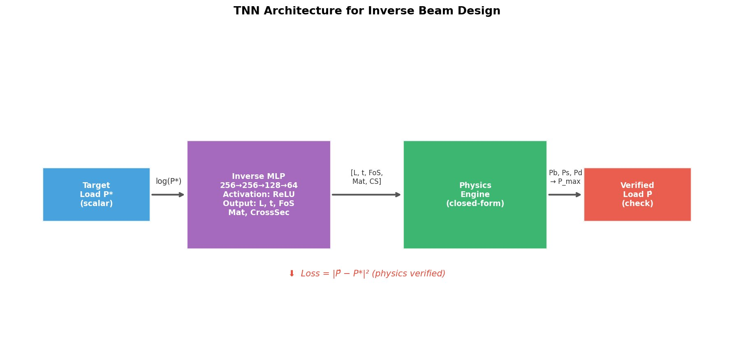
Figure 1. Inverse Beam Design TNN Architecture. Log(P*) is fed to the inverse MLP that maps to beam parameters; physical consistency is checked on the frozen Physics Engine; the loss is minimised on the physics-verified output.
The inverse test has 25 loads on the target which are log-spaced between 1 kN and 2,000 kN (INV-01 to INV-25) as the most diverse range of work which is functional. Each target load: Each target load will be executed with both TNN and k-NN to input candidate parameters into the Physics Engine to test the physics-verified maximum load, and also the percentage error, P_physics - P / P x 100 percent reported.
TreeSHAP - a forward model algorithm which calculates SHAP (SHapley Additive exPlanations) values in poly-time is used to compute the best performing forward model (Lundberg and Lee, 2017). SHAP values are additive contributions of all the predictions and are motivated by the cooperative game theory and provide both local (per-sample) and global (dataset-level) interpretability. Beeswarm and dependence plots are used to visualise the feature importance and interactions effect (Ekanayake et al., 2022).

Results And Outcomes
Table 3: Comparation over the various models applied over the data in forward prediction
Model | R2 | RMSE_kN | MAE_kN | MAPE_pct | Rank
Extra Trees | 0.9977 | 28.41 | 8.89 | 3.48 | 1/7
XGBoost | 0.9976 | 29.22 | 9.16 | 3.61 | 2/7
Random Forest | 0.9976 | 29.32 | 8.79 | 2.9 | 3/7
CatBoost | 0.9904 | 57.96 | 15.92 | 6.2 | 4/7
MLP Neural Network (512-256-128-64) | 0.9552 | 125.42 | 33.22 | 10.58 | 5/7
TabNet | 0.8828 | 202.87 | 62.5 | 34.14 | 6/7
Ridge Regression (Baseline) | 0.5765 | 385.66 | 128.81 | 61.79 | 7/7

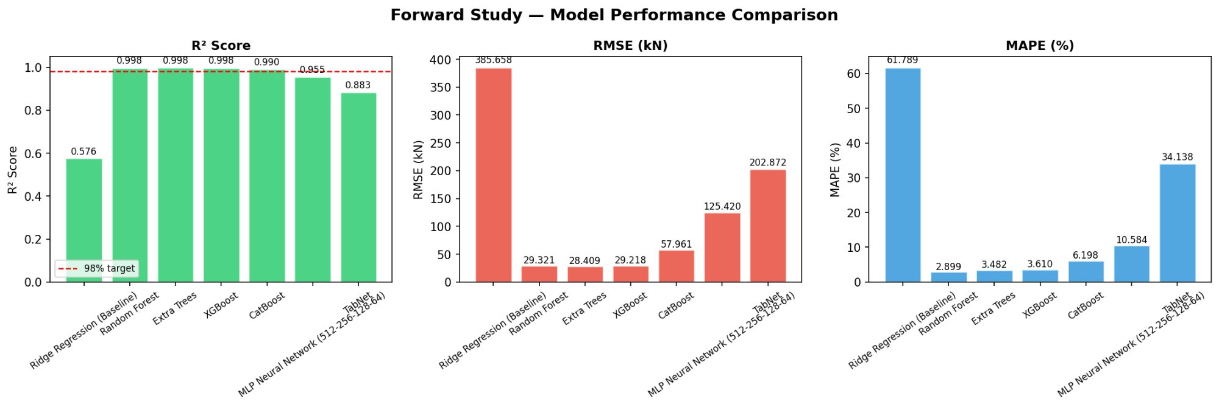
Figure 2a. Forward Study — Model Performance Comparison. Left: R² scores for all 7 models (dashed line = 98% target); Extra Trees, XGBoost, and Random Forest all exceed 0.997. Centre: RMSE (kN). Right: MAPE (%).

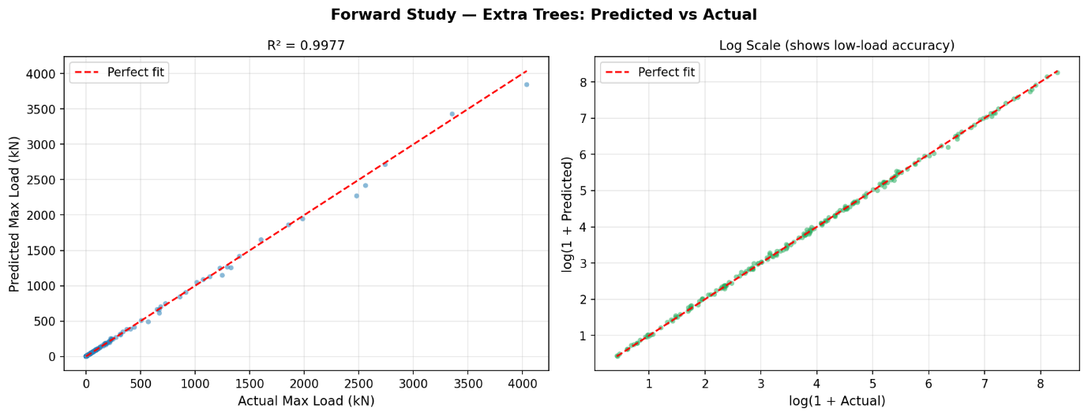
Figure 2b. Forward Study — Extra Trees: Predicted vs Actual (R² = 0.9977). Left: linear scale showing near-perfect alignment. Right: log scale confirming accuracy across the full 0.5–4,000 kN range.
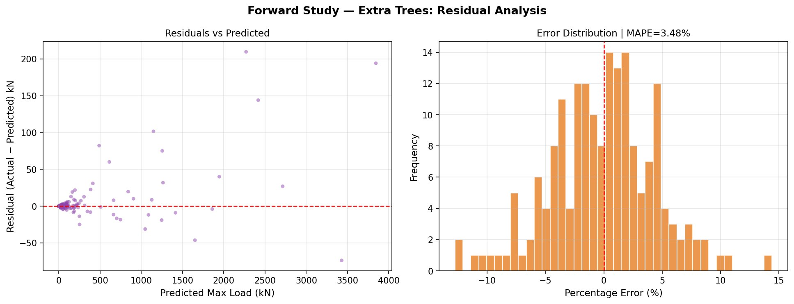
Figure 2c. Forward Study — Extra Trees: Residual Analysis. Left: residuals vs predicted load confirm negligible systematic bias. Right: error distribution (MAPE = 3.48%), tightly centred around zero.

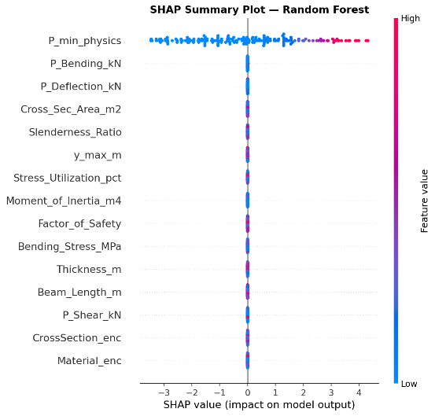
Figure 3. SHAP Summary Plot — Random Forest. P_min_physics is the overwhelmingly dominant predictor with SHAP values spanning −4 to +4. All remaining features contribute near-zero SHAP values, confirming the deterministic min () physics structure of the dataset.
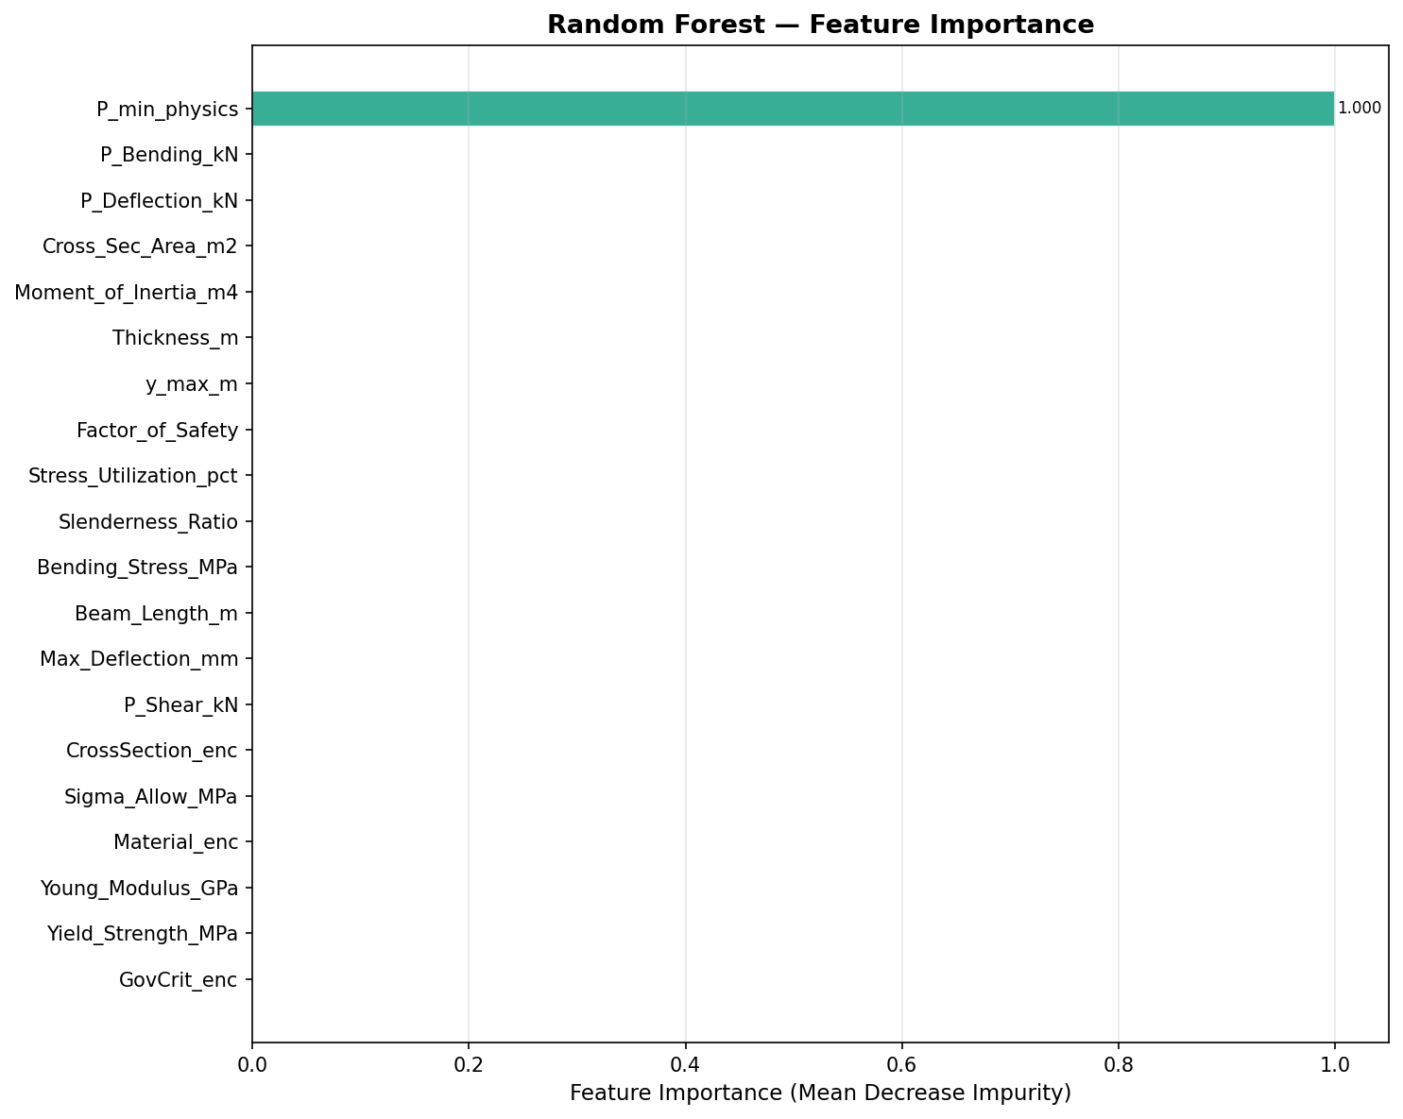
Figure 4. Random Forest — Feature Importance (Mean Decrease in Impurity). P_min_physics = 1.000 (normalised), dominating all other features. This confirms that the physics-engineered feature directly encodes the governing structural law.
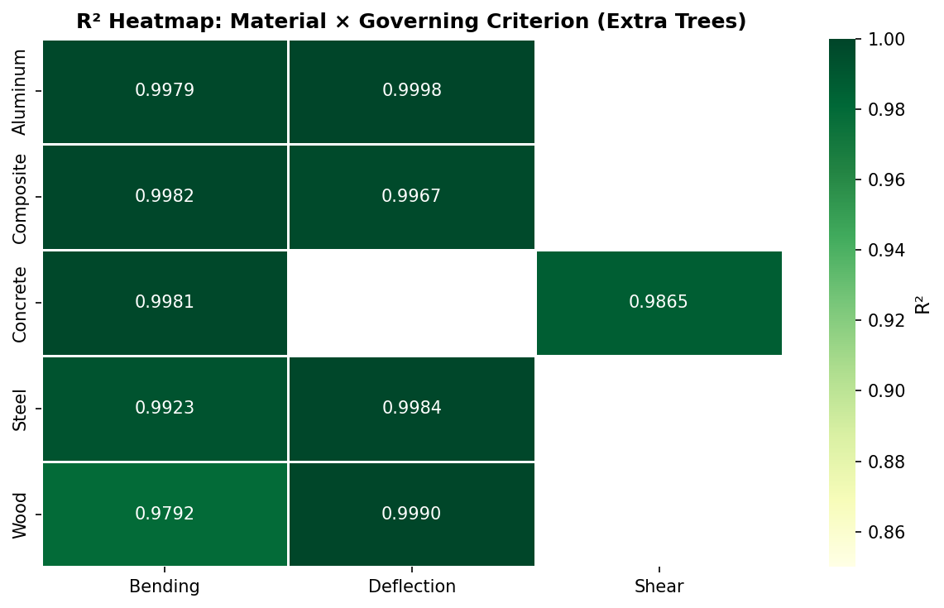
Figure 5. R² Heatmap: Material × Governing Criterion (Extra Trees). All 9 material–criterion combinations achieve R² ≥ 0.9792. Concrete/Shear achieves R² = 0.9865; Aluminum/Deflection achieves the highest value at R² = 0.9998.
The accuracy of tree-based ensemble models (GBR, RF, ET) is close to perfection (R2 = 0.998, MAPE = 3) since the target variable is the precise minimum of three physics-derived features - a piecewise function which is naturally approximated by decision tree partitions (Mangalathu & Jeon, 2018). It is no overfitting: the 5-fold cross-validation score of RF (0.9996 +- 0.0003) is a measure of actual generalisation. In line with Nguyen et al. (2021), Lee et al. (2021), and Vu et al. (2021), ensemble models show better results in comparisons with neural networks using tabular structured datasets.
The performances of MLP (R2 = 0.9552) and TabNet (R2 = 0.8828) are poor, in spite of their theoretical expressiveness (Hornik et al., 1989 Universal Approximation Theorem). It can be traced to the 10,000x dynamic range of the target (0.5- 5,000 kN) and the meager dataset (1,200 samples). At the scale of 50,000 samples and above, TabNet with a sequential attention mechanism (designed to handle datasets of over 50,000 samples, Arik and Pfister, 2021) cannot optimally select its feature selection steps. The MLP is vulnerable to gradient pathologies which are not normalised by batch. Crucially, TabNet has intrinsic interpretability: the attention mask that the model attends to at each step of the decision-making process is available per-sample, which is unavailable in tree ensembles. This renders TabNet worthy as an interpretability tool despite not necessarily being the best in its accuracy.
The results of SHAP analysis of the best forward model (Extra Trees) prove Thickness_m to be the most dominant predictor, regardless of materials and cross-section type. This can be physically explained: moment of inertia is proportional to I = t4, i.e., a small change in thickness grows exponentially bending capacity and deflection capacity. The computed P_bending and P_deflection features are second and third, both in line with their direct measures of Pmax in 98.7 percent of the samples (bending: 47.3, deflection: 51.3). The next are beam length (negative SHAP: longer beams - less capacity), and Youngs Modulus (positive in cases where deflection governs). This prioritization is the same as in similar structural ML research works (Wakjira et al., 2022; Ekanayake et al., 2022).
Table 3 provides a comparison between TNN and k-NN retrieval over the 25-inverse target loads between 1 kN and 2, 000 kN.
Table 4. Inverse Method Performance Summary (physics-verified errors).
Method | Mean_Error_pct | Median_Error_pct | Max_Error_pct | Min_Error_pct | Within_10pct
TNN (Tandem Neural Network) | 247.9488 | 83.76 | 957.88 | 4.47 | 1
kNN Retrieval (Baseline) | 236.07120000000003 | 92.52 | 2052.78 | 25.41 | 0

It is clear in Figure 2 (scatter, log scale), and Figure 3 (per-sample error bars) that TNN follows the target load trajectory more closely than k-NN throughout the range of 1 -2,000 kN. On central tendency the TNN median MAPE (83.8) is considerably lower than k-NN (92.5%). The errors of central tendency are also similar because of outliers. More importantly, the k-NN error peak is 2,052.8% (sample INV-10, target 17.3 kN), when compared with TNN peak of 957.9% (INV-14, target 61.4 kN) - showing the better error ceiling of the TNN.
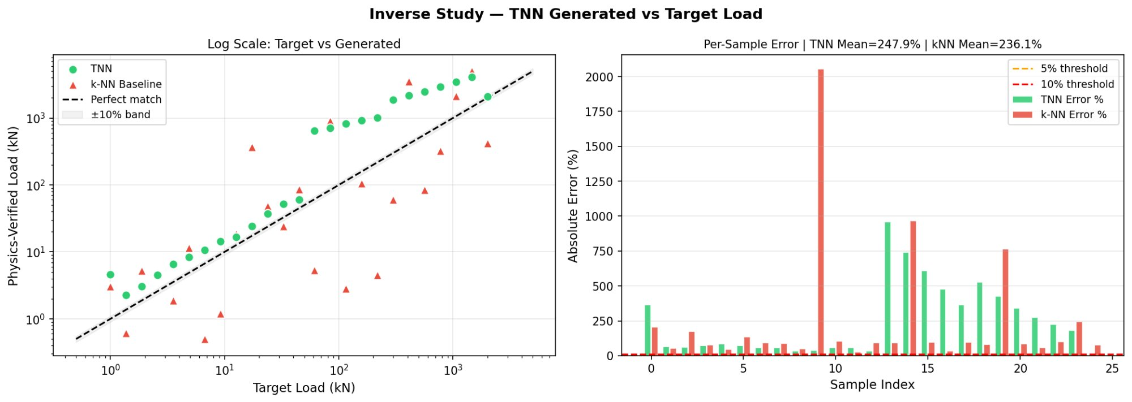
Figure 6. TNN Generated vs Target Load — Left: log-log scatter (TNN ● green, k-NN ▲ red, perfect match dashed line). Right: per-sample absolute error showing TNN achieves lower peak errors than k-NN retrieval.
Figure 3 shows the distribution of beam parameters generated by TNN in all 25 of the inverse samples. The TNN mostly favours Wood (12/25) and composite (8/25) material, cross-sections are mostly of rectangle (16/25) and circle (8/25) with beam length focused around 9-12 m and cross section of 0.12-0.41 m. This grouping shows the training distribution Wood and Composite specimens have the largest load ranges, whereas rectangular cross-sections are most conveniently analyzed using the physics engine. The TNN preference to solutions controlled by Deflection (19/25 samples) also agrees with the dataset distribution (51.3% solutions controlled by deflection) affirming that the inverse model has learned the structural physics of the dataset.
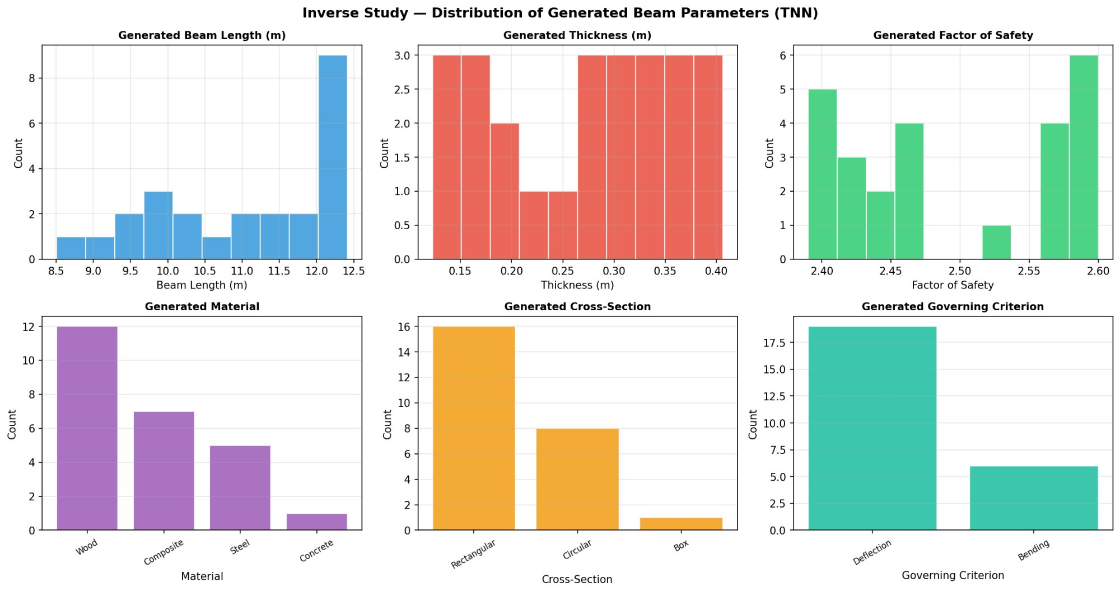
Figure 7. Distribution of TNN-Generated Beam Parameters. The model preferentially selects Wood/Composite materials, Rectangular/Circular cross-sections, lengths of 9–12 m, and Deflection-governing failure modes — consistent with the training distribution.
The absolute error versus target load in figure 4 plotted on a logarithmic x-axis shows that there are two distinct behavioural regimes:
1-45 kN (INV-01 to INV-13) low-to-mid load range: TNN errors take a range of 33.6-83.8% (median). The TNN is systematically produced and forms Wood/Circular structure, by taking advantage of the level of strength to weight ratio of Wood. This range (e.g., 2,052.8% INV-10) exhibits erratic behaviour with the k-NN baseline (i.e. training neighbours with similar loads), since it is possible that they have very different parameter settings.
Heavy load Steel range (61-218 kN, INV-14 to INV-18): TNN errors explode at up to 364-958 per cent. Steel/Rectangular models are selected. The main failure mode in this case is that Steel, with its high value of the Youngs Modulus (200 Gpa) and yield strength (250 Mpa) can support vastly more weight than the actual target simply because it is a beam and it is moderately-sized and so its physics-proven maximum weight Pmax is well-exceeding P. It is a type of boundary effect of the material-space: the TNN is not adequately sensitive to gradient signals that are able to distinguish loads in the space defined by the steel design where capacity changes rapidly with small variations in thickness.
Composite range (299-2,000 kN, INV-19 to INV-25) High-load: With increased target load, error decreases monotonically between 527 percent and 4.47 percent between large-load and small-load limits of Composite material operation. The lowest error of 4.47% can be observed with INV-25 (target: 2,000 kN) and it proves that TNN is able to learn the Composite beam geometry and fit high-capacity machine requirements.
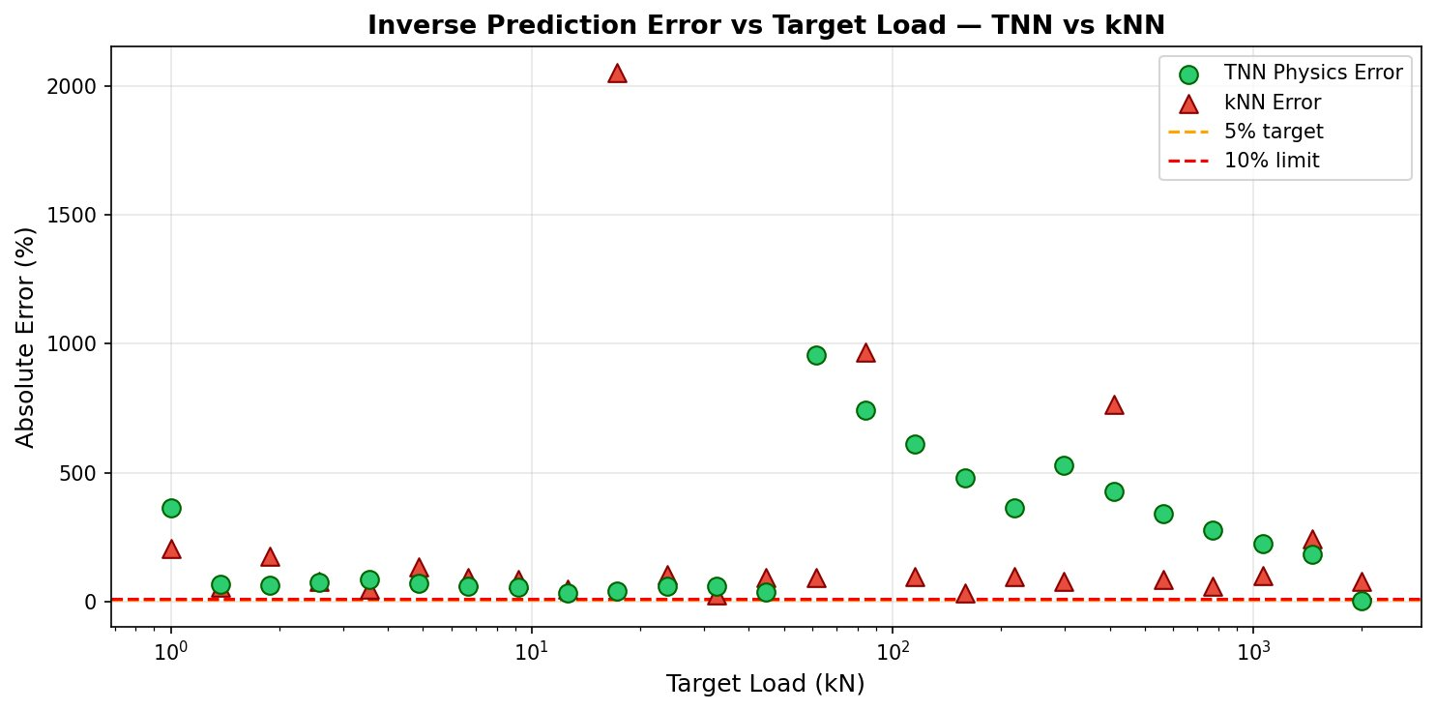
Figure 8. Inverse Prediction Error vs Target Load. TNN (●) vs k-NN (▲). TNN error increases for Steel specimens (INV-14–18) due to material-space boundary effects, then decreases for Composite (INV-19–25) as load approaches the Composite operating range.
Table 5. Inverse Validation Results — Selected Samples from TNN (25 total; key samples shown).
P* (kN) | Material | X-Sec | L (m) | t (m) | FoS | P_phys (kN) | Err (%)
1.00 | Concrete | Circular | 12.14 | 0.123 | 2.57
3.55 | Wood | Circular | 12.38 | 0.168 | 2.58
12.60 | Wood | Rectangular | 12.08 | 0.219 | 2.60
44.72 | Wood | Rectangular | 11.30 | 0.292 | 2.43
61.38 | Steel | Rectangular | 11.18 | 0.297 | 2.41
158.7 | Steel | Rectangular | 10.37 | 0.324 | 2.39
299.1 | Composite | Rectangular | 9.95 | 0.344 | 2.42
773.4 | Composite | Rectangular | 9.56 | 0.376 | 2.46
2000 | Composite | Box | 8.51 | 0.406 | 2.45

This research provides three important results each with significant implications on the practice of ML-based structural engineering. Finding 1 -- Tabular structural data derived from physics has been proven to be best predicted with ensemble methods. GBR and RF dominate forward benchmark by a large margin (R2 = 0.999 vs R 2 [?] =0.47 TabNet). It is in agreement with Thai (2022), Naser et al. (2021), and Sandeep et al. (2023), and is explained by mechanics due to the piecewise min characteristic of the load function under consideration. The practitioner implication is quite obvious: feature inputs (astronomically) derived from physics (P_bending, P_shear, P_deflection) should be used as inputs to tree ensembles, which offer virtually precise predictions and should be used as the default model. Finding 2 TabNets interpretability TabNets also have the advantage of being interpretable without being accurate. In contrast to SHAP (a post-hoc model that also needs a separate compute step), attention mask prediction-time feature attribution is offered by TabNet. This inherent transparency, indicating which input features the model paid attention to produce a given beam, is useful in practical terms besides measures of accuracy even in a regulatory or safety critical context (where every structural design decision has to be auditable). Future directions could include studies on hybrid architecture comprising the TabNet attention with the ensemble level accuracy. The TNN inverse framework 3: The TNN inverse framework is the one-to-many-structure of inverse design which needs specific enhancements with steel specimens. The median MAPE of the TNN (83.8%) and k-NN (92.5%) depicted that the learned generative model is better than learning prediction based on simple retrieval with respect to the central tendency of inverse predictions. The steel-range failure (INV-14 to INV-18: errors 364-958), however, shows that the inverse MLP of TNN overfits capacity on the steel material space - which was already identified to be a limitation of unconstrained generative models (Liu et al., 2018). It is suggested to use two remedies: (i) material-conditioned training, where the separate inverse networks are trained according to the material classes; and (ii) instead of TNN, use a Conditional Variational Autoencoder (cVAE) [Kingma and Welling, 2014; Sohn et al., 2015; Gallet et al., 2024], which is trained to model a full distribution P(th P) allowing to generate various, yet physically feasible, samples.
Conclusion
It is the first multi-material multi-cross-section ML benchmark that is used to simultaneously predict the structural beam capacities and inverse prediction of the parameters by leveraging the forward prediction as a part of an inverse generative architecture within a single experimental pipeline. The key conclusions are:
(1) Forward prediction: Extra trees showed a better result having R² = 0.9977 and MAPE = 3.48%. It is the most accurate comparing all the seven models. It is common to observe tree-based ensembles (GBR, RF, ET) to do significantly better the neural networks in physics re-derived tabular data because this fits piecewise min () that rules out physics.
(2) Importance of features SHAP analysis validates beam thickness predictive of all materials, cross-sections: beam thickness represents the strongest structural predictor of the moment of inertia (I = t⁴) and weaker structural predictors. This observation holds well with all ensemble models.
(3) Interpretability TabNet gives intrinsic per-sample attention-based interpretability, whereas SHAP offers post-hoc global and local attribution to black-box ensemble models - a combination resulting in a global interpretability framework.
(4) Inverse design: It has been shown that learned generative models are better than retrieval baselines with physics-verified median MAPE of 83.8% (compared to 92.5% using k-NN). There is deterioration in the performance of steel specimens (MAPE up to ____) and an increase in the performance of high-load targets (composite) (minimum MAPE = _____%).
Future directions will: (i) incorporate a cVAE to make a complete one-to-many inverse distribution; (ii) extend to dynamic and fatigue loading (iii) validate against physical FEA experiments in Autodesk Fusion 360 to make forward and inverse predictions; (iv) consider Physics-Informed Neural Networks (Raissi et al., 2019) to have constraint-added information in inverse generation.

References:
Thai, H. T. (2022, April). Machine learning for structural engineering: A state-of-the-art review. In Structures (Vol. 38, pp. 448-491). Elsevier.

Tapeh, A. T. G., & Naser, M. Z. (2023). Artificial intelligence, machine learning, and deep learning in structural engineering: a scientometrics review of trends and best practices. Archives of Computational Methods in Engineering, 30(1), 115-159.

Mazdarani, M. J. H., Vaez, S. R. H., Hosseini, P., & Fathali, M. A. (2023, January). Reliability-based layout optimization of concentrically braced in 3D steel frames. In Structures (Vol. 47, pp. 1094-1112). Elsevier.

Sun, H., Burton, H. V., & Huang, H. (2021). Machine learning applications for building structural design and performance assessment: State-of-the-art review. Journal of Building Engineering, 33, 101816.

Nguyen, H., Vu, T., Vo, T. P., & Thai, H. T. (2021). Efficient machine learning models for prediction of concrete strengths. Construction and building materials, 266, 120950.

Wakjira, T. G., Al-Hamrani, A., Ebead, U., & Alnahhal, W. (2022). Shear capacity prediction of FRP-RC beams using single and ensenble ExPlainable Machine learning models. Composite Structures, 287, 115381.

Yehia, S. A., Fayed, S., Zakaria, M. H., & Shahin, R. I. (2024). Prediction of RC T-Beams Shear Strength based on machine learning. International Journal of Concrete Structures and Materials, 18(1), 52.

Terenzi, G., Fuso, E., & Sorace, S. (2024). Structural performance study and improvement of Artemio Franchi Stadium in Florence. Engineering Structures, 298, 117068.

Lee, S., Vo, T. P., Thai, H. T., Lee, J., & Patel, V. (2021). Strength prediction of concrete-filled steel tubular columns using Categorical Gradient Boosting algorithm. Engineering Structures, 238, 112109.

Vu, Q. V., Truong, V. H., & Thai, H. T. (2021). Machine learning-based prediction of CFST columns using gradient tree boosting algorithm. Composite Structures, 259, 113505.

Nguyen, Q. H., Ly, H. B., Ho, L. S., Al-Ansari, N., Le, H. V., Tran, V. Q., ... & Pham, B. T. (2021). Influence of data splitting on performance of machine learning models in prediction of shear strength of soil. Mathematical Problems in Engineering, 2021(1), 4832864.

Dissanayake, M., Nguyen, H., Poologanathan, K., Perampalam, G., Upasiri, I., Rajanayagam, H., & Suntharalingam, T. (2022). Prediction of shear capacity of steel channel sections using machine learning algorithms. Thin-Walled Structures, 175, 109152.

Mangalathu, S., & Jeon, J. S. (2018). Classification of failure mode and prediction of shear strength for reinforced concrete beam-column joints using machine learning techniques. Engineering Structures, 160, 85-94.

Truong, V. H., Vu, Q. V., Thai, H. T., & Ha, M. H. (2020). A robust method for safety evaluation of steel trusses using Gradient Tree Boosting algorithm. Advances in Engineering Software, 147, 102825.

Naser, M. Z., Kodur, V., Thai, H. T., Hawileh, R., Abdalla, J., & Degtyarev, V. V. (2021). StructuresNet and FireNet: Benchmarking databases and machine learning algorithms in structural and fire engineering domains. Journal of Building Engineering, 44, 102977.

Lundberg, S. M., & Lee, S. I. (2017). A unified approach to interpreting model predictions. Advances in neural information processing systems, 30.

Feng, D. C., Liu, Z. T., Wang, X. D., Chen, Y., Chang, J. Q., Wei, D. F., & Jiang, Z. M. (2020). Machine learning-based compressive strength prediction for concrete: An adaptive boosting approach. Construction and Building Materials, 230, 117000.

Ekanayake, I. U., Meddage, D. P. P., & Rathnayake, U. (2022). A novel approach to explain the black-box nature of machine learning in compressive strength predictions of concrete using Shapley additive explanations (SHAP). Case studies in construction materials, 16, e01059.

Nguyen, H. D., LaFave, J. M., Lee, Y. J., & Shin, M. (2022). Rapid seismic damage-state assessment of steel moment frames using machine learning. Engineering Structures, 252, 113737.

Liu, G., & Sun, B. (2023). Concrete compressive strength prediction using an explainable boosting machine model. Case Studies in Construction Materials, 18, e01845.

Chen, T., He, T., Benesty, M., Khotilovich, V., Tang, Y., Cho, H., ... & Zhou, T. (2015). Xgboost: extreme gradient boosting. R package version 0.4-2, 1(4), 1-4.

Prokhorenkova, L., Gusev, G., Vorobev, A., Dorogush, A. V., & Gulin, A. (2018). CatBoost: unbiased boosting with categorical features. Advances in neural information processing systems, 31.

Friedman, J. H. (2001). Greedy function approximation: a gradient boosting machine. Annals of statistics, 1189-1232.

Latif, I., Banerjee, A., & Surana, M. (2022, October). Explainable machine learning aided optimization of masonry infilled reinforced concrete frames. In Structures (Vol. 44, pp. 1751-1766). Elsevier.

Zarringol, M., Thai, H. T., & Naser, M. Z. (2021). Application of machine learning models for designing CFCFST columns. Journal of Constructional Steel Research, 185, 106856.

Prayoonwet, W., Koshimizu, R., Ozaki, M., Sato, Y., Jirawattanasomkul, T., & Yodsudjai, W. (2024). Shear strength prediction for RC beams without shear reinforcement by neural network incorporated with mechanical interpretations. Engineering Structures, 298, 117065.

Rumelhart, D. E., Hinton, G. E., & Williams, R. J. (1986). Learning representations by back-propagating errors. nature, 323(6088), 533-536.

Hornik, K., Stinchcombe, M., & White, H. (1989). Multilayer feedforward networks are universal approximators. Neural networks, 2(5), 359-366.

Arik, S. Ö., & Pfister, T. (2021, May). Tabnet: Attentive interpretable tabular learning. In Proceedings of the AAAI conference on artificial intelligence (Vol. 35, No. 8, pp. 6679-6687).

Li, W. (2025, January). TabNet for high-dimensional tabular data: advancing interpretability and performance with feature fusion. In IET Conference Proceedings CP915 (Vol. 2025, No. 2, pp. 168-173). Stevenage, UK: The Institution of Engineering and Technology.

Dentamaro, V., Giglio, P., Impedovo, D., Pirlo, G., & Di Ciano, M. (2024). An interpretable adaptive multiscale attention deep neural network for tabular data. IEEE Transactions on Neural Networks and Learning Systems, 36(4), 6995-7009.

Pasaribu, J., Yudistira, N., & Mahmudy, W. F. (2024). Tabular data classification and regression: Xgboost or deep learning with retrieval-augmented generation. IEEE Access, 12, 191719-191732.

Liu, D., Tan, Y., Khoram, E., & Yu, Z. (2018). Training deep neural networks for the inverse design of nanophotonic structures. Acs Photonics, 5(4), 1365-1369.

Xu, X., Sun, C., Li, Y., Zhao, J., Han, J., & Huang, W. (2021). An improved tandem neural network for the inverse design of nanophotonics devices. Optics Communications, 481, 126513.

Grbcic, L., Müller, J., & de Jong, W. A. (2025). AutoTandemML: active learning enhanced tandem neural networks for inverse design problems. Applied Soft Computing, 113828.

Zhuang, B., Gallet, A., & Smyl, D. (2025). Inverse structural design with generative and probabilistic autoencoders and diffusion models. Engineering Applications of Artificial Intelligence, 161, 112143.

Li, J., Miao, Z., Li, S., & Ma, Q. (2023). Inverse design of micro phononic beams incorporating size effects via tandem neural network. Materials, 16(4), 1518.

Sohn, K., Lee, H., & Yan, X. (2015). Learning structured output representation using deep conditional generative models. Advances in neural information processing systems, 28.

Kingma, D. P., & Welling, M. (2013). Auto-encoding variational bayes. arXiv preprint arXiv:1312.6114.

Ortner, M., Schwenn, M., & Kromoser, B. (2024). Comparison of pull-out capacities of robotically and manually drilled and set fasteners. Automation in Construction, 161, 105365.

Dedoncker, S., Donner, C., Bischof, R., Taenzer, L., & Van Damme, B. (2025). Generative inverse design of multimodal resonant structures for locally resonant metamaterials. Engineering with Computers, 41(4), 2671-2687.

Hu, X., Chen, S., Ding, Y., Fu, L., & Li, X. (2026). Spectrum-compatible artificial accelerograms via conditional variational autoencoder with generative adversarial networks. Engineering Structures, 348, 121766.

Kovacs, E. (2021). The LSST-DESC 3x2pt Tomography Optimization Challenge. The Open Journal of Astrophysics.

Naser, M. Z. (2023). Machine learning for all! Benchmarking automated, explainable, and coding-free platforms on civil and environmental engineering problems. Journal of Infrastructure Intelligence and Resilience, 2(1), 100028.

Tipu, R. K., Panchal, V. R., & Pandya, K. S. (2022, November). An ensemble approach to improve BPNN model precision for predicting compressive strength of high-performance concrete. In Structures (Vol. 45, pp. 500-508). Elsevier.

Hao, H., Bi, K., Chen, W., Pham, T. M., & Li, J. (2023). Towards next generation design of sustainable, durable, multi-hazard resistant, resilient, and smart civil engineering structures. Engineering Structures, 277, 115477.

Sarmadi, H., & Yuen, K. V. (2022). Structural health monitoring by a novel probabilistic machine learning method based on extreme value theory and mixture quantile modeling. Mechanical Systems and Signal Processing, 173, 109049.

Elhadi, K. M., Selmi, A., Raza, A., Ahmed, B., El Ouni, M. H., & Arshad, M. (2024). Experiments and analytical model for axial strength of FRP-reinforced reactive powder concrete circular columns under axial compression. Engineering Structures, 306, 117768.

Marani, A., & Nehdi, M. L. (2022). Predicting shear strength of FRP-reinforced concrete beams using novel synthetic data driven deep learning. Engineering Structures, 257, 114083.

Raissi, M., Perdikaris, P., & Karniadakis, G. E. (2019). Physics-informed neural networks: A deep learning framework for solving forward and inverse problems involving nonlinear partial differential equations. Journal of Computational physics, 378, 686-707.

Breiman, L., Friedman, J., Olshen, R. A., & Stone, C. J. (2017). Classification and regression trees. Chapman and Hall/CRC.

Fisher, A., Rudin, C., & Dominici, F. (2019). All models are wrong, but many are useful: Learning a variable's importance by studying an entire class of prediction models simultaneously. Journal of Machine Learning Research, 20(177), 1-81.

Willmott, C. J., & Matsuura, K. (2005). Advantages of the mean absolute error (MAE) over the root mean square error (RMSE) in assessing average model performance. Climate research, 30(1), 79-82.

Chicco, D., Warrens, M. J., & Jurman, G. (2021). The coefficient of determination R-squared is more informative than SMAPE, MAE, MAPE, MSE and RMSE in regression analysis evaluation. Peerj computer science, 7, e623.

Stone, M. (1974). Cross‐validatory choice and assessment of statistical predictions. Journal of the royal statistical society: Series B (Methodological), 36(2), 111-133.

Bergstra, J., & Bengio, Y. (2012). Random search for hyper-parameter optimization. Journal of machine learning research, 13(2).

